Depth First Search (DFS)
Aim:
To traverse a graph using DFS.
Objective:
To explore nodes deeply before backtracking.
Algorithm:
- Start at root node.
- Visit node.
- Recursively visit adjacent nodes.
- Backtrack when required.
FLOW CHART:
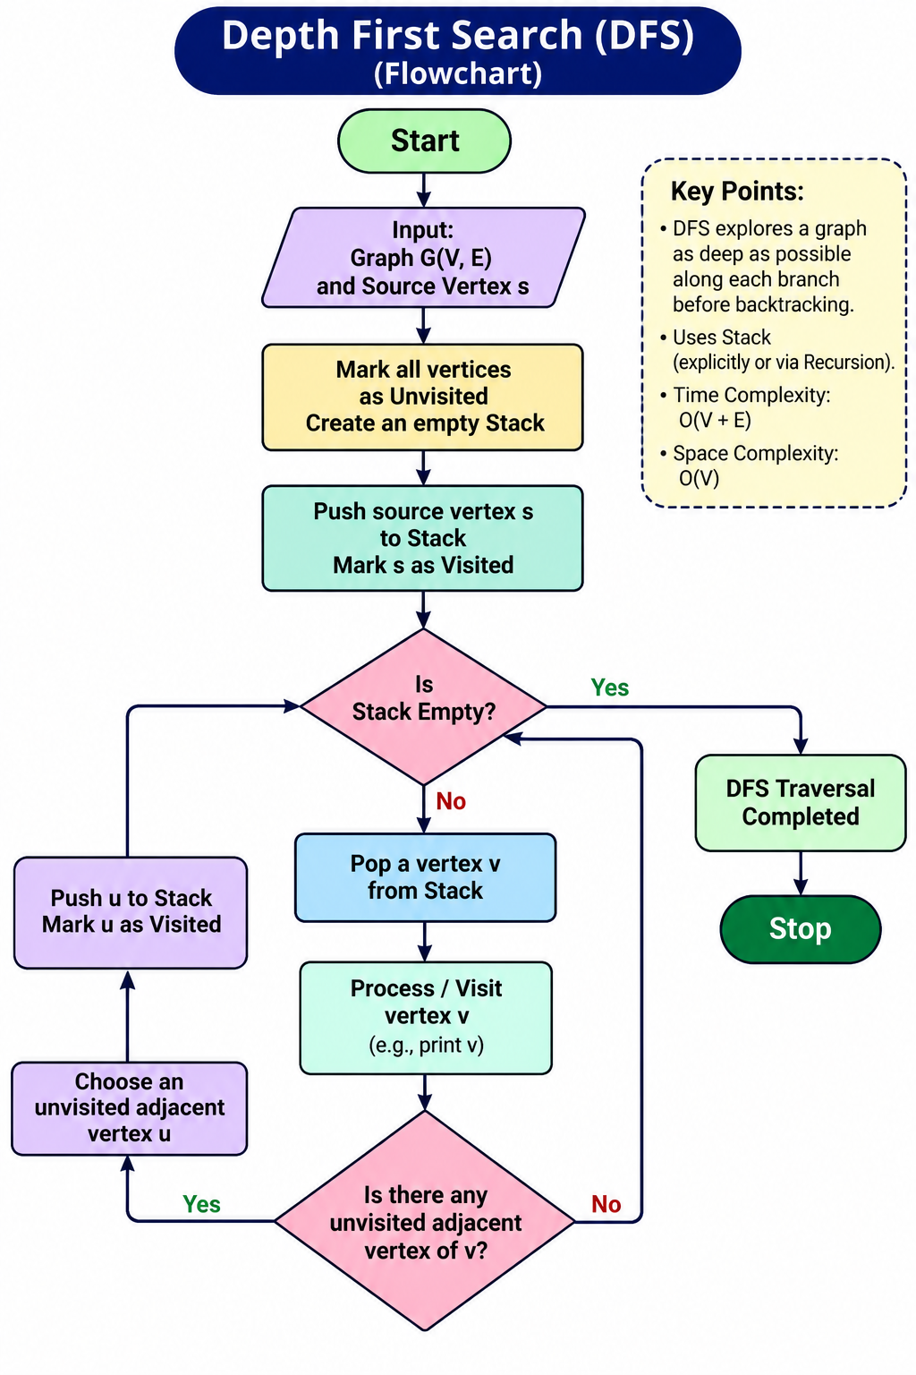
PYTHON CODE:
graph = {}

n = int(input("Enter number of nodes: "))

for i in range(n):
node = input("Enter node name: ")
neighbors = input(f"Enter neighbors of {node} (space-separated): ").split()
graph[node] = neighbors

start = input("Enter starting node: ")

visited = []

def dfs(node):
if node not in visited:
visited.append(node)
for neighbor in graph[node]:
dfs(neighbor)

dfs(start)

print("DFS Traversal:", visited)
OUTPUT:
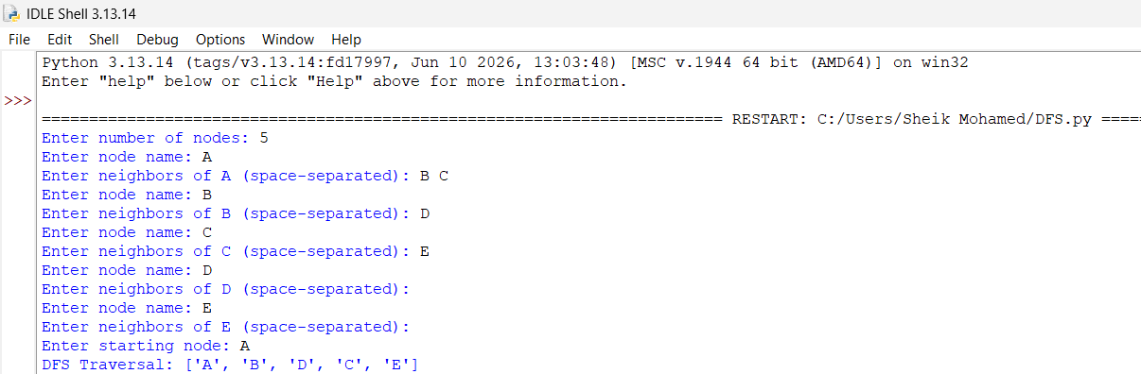

Result:
Graph traversed successfully.
Conclusion:
DFS explores depth before breadth.

